|  |
| --- |
| SHARP |
| Installing SQL Server 2005 |
| Windows Server 2008 R2 Standard – 64bit |

|  |
| --- |
|  |

# Installing Microsoft SQL Server 2005 Express

* 1. Double Click on Setup.exe

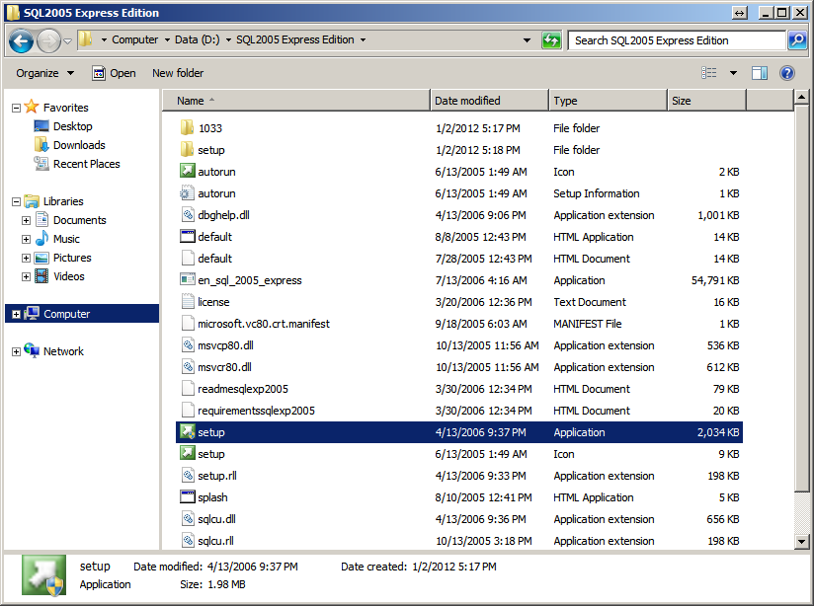

Figure 1: Setup

* 1. Click “Run Program”

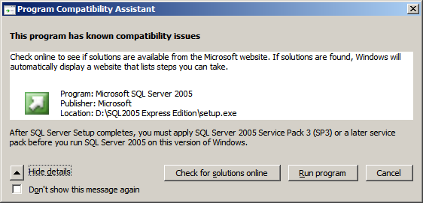

Figure 2: Compatibility Assistant

*Note: You must apply SQL Server Pack 3 later to function properly*

* 1. “Click Next >”

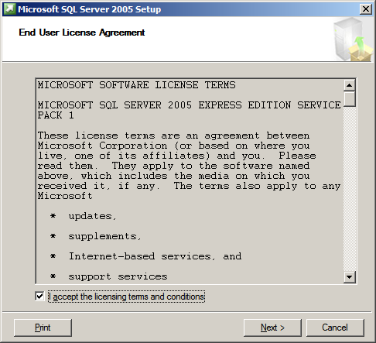

Figure 3: End User License Agreement

* 1. Click “Install”

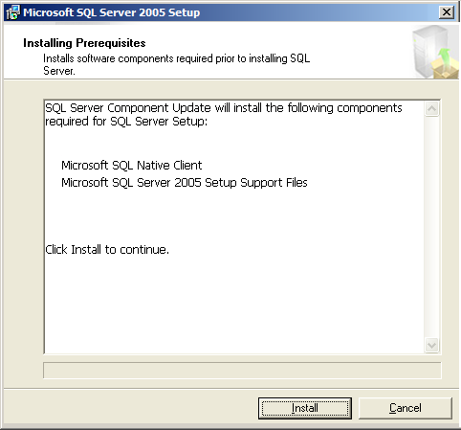

Figure 4: Installing Prerequisites

* 1. Click “Next >”

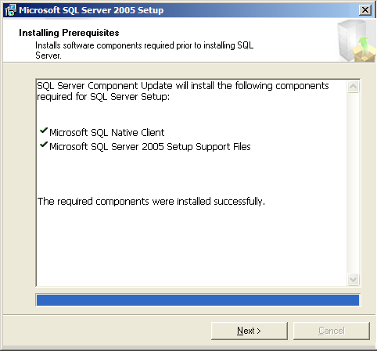

Figure 5: Installing Prerequisites

* 1. Click “Next >”

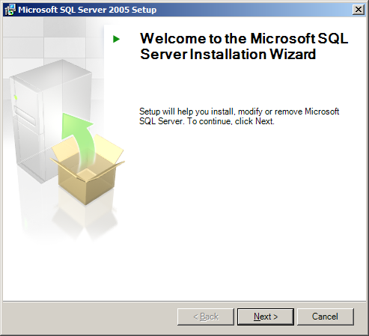

Figure 6: Installation wizard

* 1. Click “Next >”

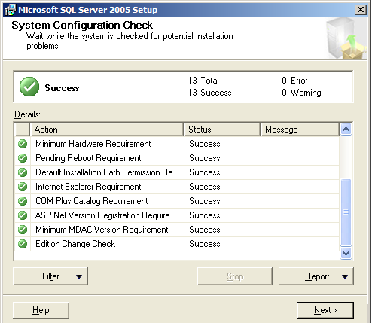

Figure 7: System Configuration Check

* 1. Click “Next >”

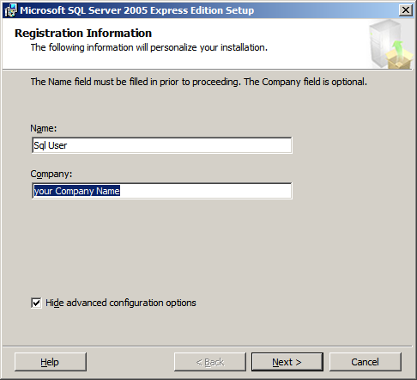

Figure 8: Registration Information

* 1. Click “Next >”

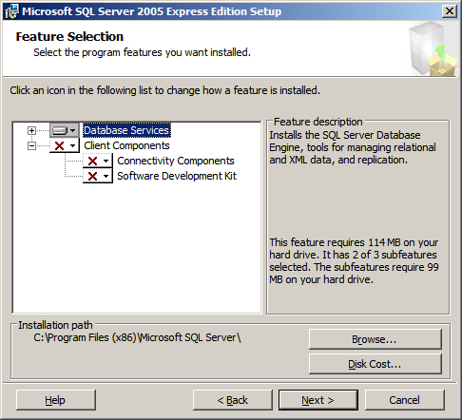

Figure 9: Feature selection

Select “Default Instance” & Click “Next >”

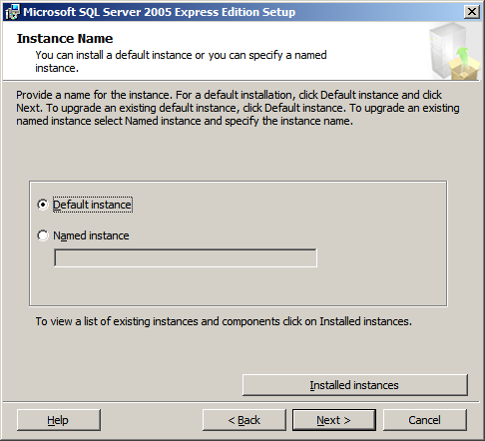

1. Select “Mixed Mode (Windows authentication and SQL Server authentication)”
2. Enter Password in “Enter password” text field.
3. Enter Same Password in “Confirm password” text field.
4. Click “Next >”

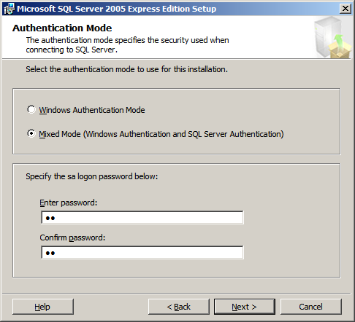

Figure 10: Authentication Mode

* 1. Click “Next >”

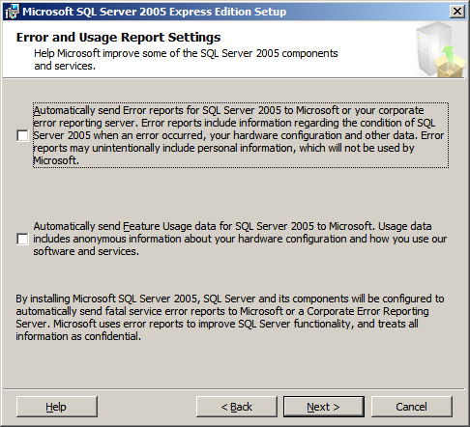

Figure 11: Error and Usage Report settings

* 1. Click “Install”

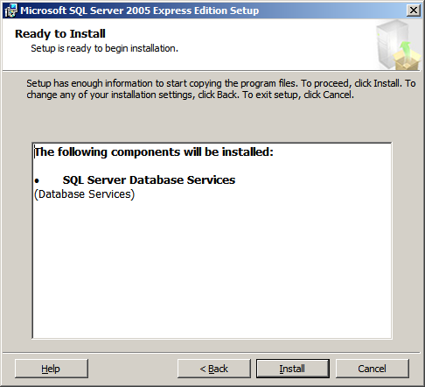

Figure 12: Ready to Install

* 1. Click “Next >>”

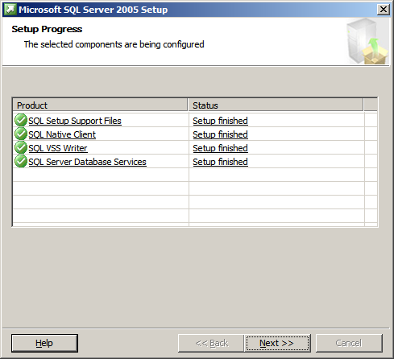

Figure 13: Setup progress

* 1. Click “Finish”

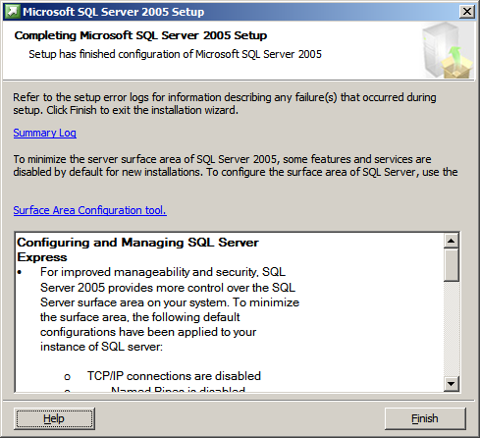

Figure 14: Completing Microsoft SQL Server 2005 Setup